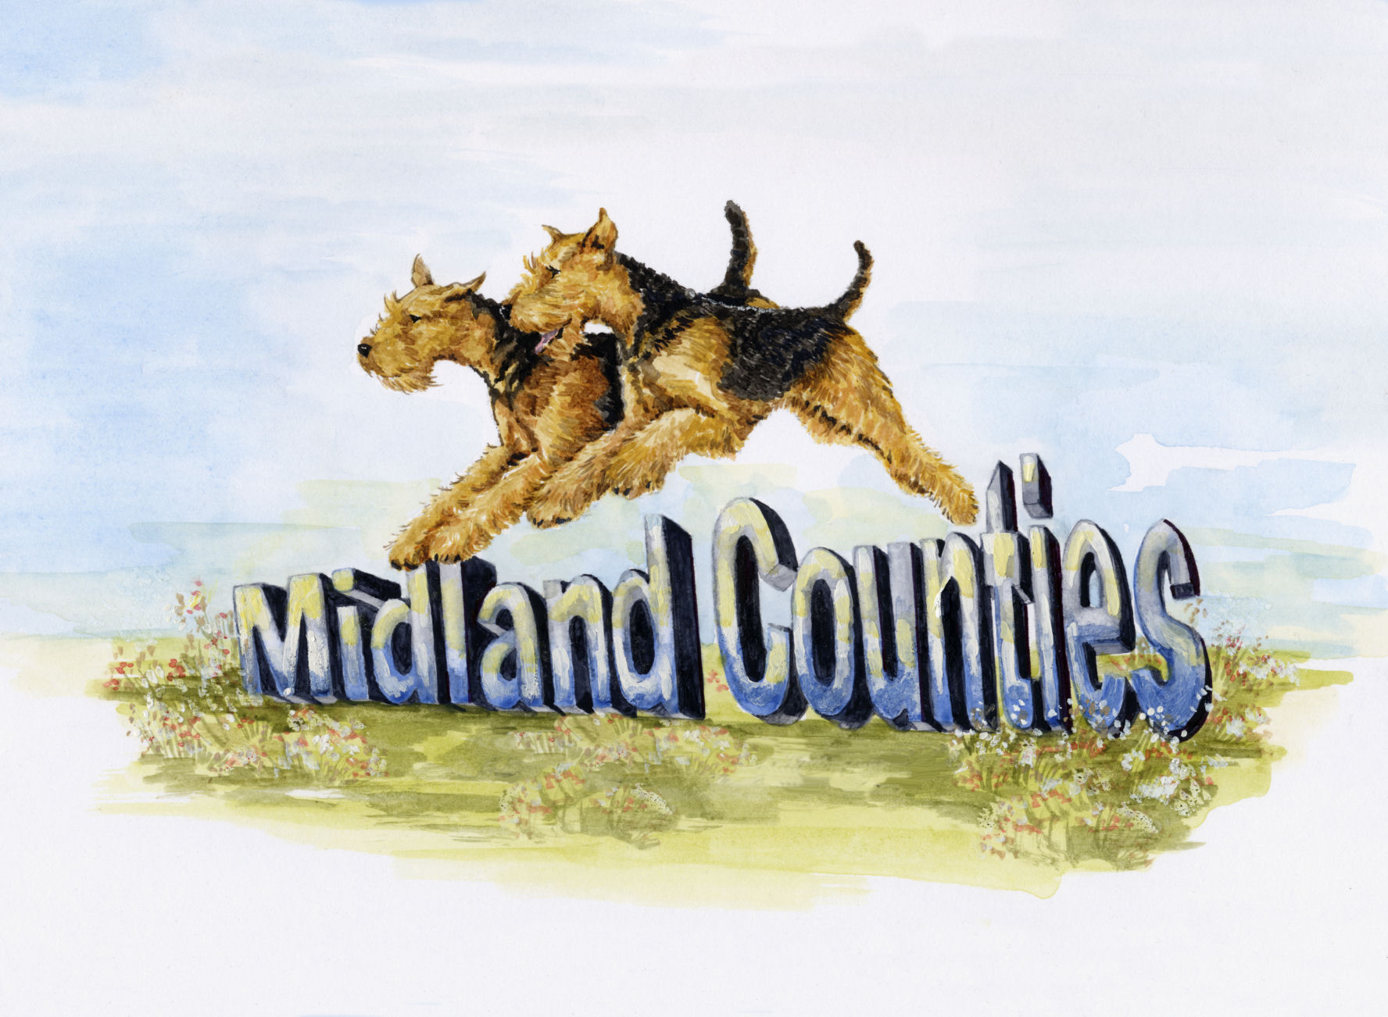
Airedale Terrier Club
Airedale Terrier Club

MIDLAND COUNTIES AIREDALE
TERRIER CLUB
GENERAL CODE OF ETHICS

All members of the Midland Counties Airedale Terrier Club undertake to abide by its general Code of Ethics.

Club members:

- Will properly house, feed, water and exercise all dogs under their care and arrange for appropriate veterinary attention if and when required.

- Will agree without reservation that any veterinary surgeon performing an operation on any of their dogs which alters the natural conformation of the animal, or who carries out a caesarean section on a bitch, may report such operation to the Kennel Club.

- Will agree that no healthy puppy will be culled. Puppies which may not conform to the Breed Standard should be placed in suitable homes.

- Will abide by all aspects of the Animal Welfare Act.

- Will not create demand for, nor supply, puppies that have been docked illegally.

- Will agree not to breed from a dog or bitch which could be in any way harmful to the dog or to the breed.

- Will not allow any of their dogs to roam at large or to cause a nuisance to neighbours or those carrying out official duties.

- Will ensure that their dogs wear properly tagged collars and will be kept leashed or under effective control when away from home.

- Will clean up after their dogs in public places or anywhere their dogs are being exhibited.

- Will only sell dogs where there is a reasonable expectation of a happy and healthy life and will help with the re-homing of a dog if the initial circumstances change.

- Will supply written details of all dietary requirements and give guidance concerning responsible ownership when placing dogs in a new home.

- Will ensure that all relevant Kennel Club documents are provided to the new owner when selling or transferring a dog, and will agree, in writing, to forward any relevant documents at the earliest opportunity, if not immediately available.

- Will not sell any dog to commercial dog wholesalers, retail pet dealers or directly or indirectly allow dogs to be given as a prize or donation in a competition of any kind. Will not sell by sale or auction Kennel Club registration certificates as stand alone items (not accompanying a dog).

- Will not knowingly misrepresent the characteristics of the breed nor falsely advertise dogs nor mislead any person regarding the health or quality of a dog.

- Members will, when breeding dogs, adopt as a minimum standard the principles, requirements and recommendations as embodied in the Kennel Club’s Assured Breeder Scheme. It is strongly recommended that members who breed should apply to join the scheme.

Breach of these provisions may result in expulsion from club membership, and/or disciplinary action by the Kennel Club and/or reporting to the relevant authorities for legal action, as appropriate.

KC/GJ September 2008 / Updated Februaryl 2012

